Activity 1: April 5, 2018 – Creative Decks

PROBLEM RESTATEMENT – Study and justify solutions for creative decks of cards

QUESTIONS –

Can a deck have just one card?

Can decks of different sizes have the same score?

Can a deck consist of one card with multiple integers?

How much does the score vary deck-to-deck?

~~~~~~~~~~~~~~~~~~~~~~~~~~~~~~~~~~~~~~~~~~~~~~~~~~~~~~~~~~~~~~~~~~~~~~~~~~~~~~

A deck of one card could appear for any value of n

Example: n = 9

9

This is a deck containing one card with one unique integer.

The score is (number of distinct cards) + (number of integers on each card)

Score: 1 + 1 = 2

When creating a deck, the integers on the cards can be repeated anywhere from 1 to n times.

“Each integer i, such that 1 <= i <= n, appears in the deck exactly i times.”

**Determine decks for n = 3, 4, 5, and 6**

n = 3

1,2 2,3 3,3 **ALSO** 1,1,1,2,2,2,3,3,3

Score: 3 + 2 = 5 Score: 1 + 9 = 10 (not as good)

n = 4

1,4,4 2,3,3 3,3,4 4,4,4

Score: 4 + 3 = 7

n = 5

1,5,5,5,5 2,3,3,4,4 4,5,5,5,5

Score: 3 + 5 = 8

n = 6

1,6,6,6,6,6 2,3,3,3,3,3 2,2,4,4,4,5

Score: 3 + 6 = 9

There become many more options for decks as n increases.

The amount of possible decks increases exponentially with the increasing of n.

As a result of this, the score will also be raised.

Attempting higher values for n

Determine decks for n = 11, 12, 13, 14

n = 11

Could simply be: 11

Score: 1 + 1 = 2

1,2,11 3,4,10 5,6,9

Score: 3 + 3 = 6

n = 12

1,2,3,4,12 5,6,7,8,11 8,9,10,11,12

Score: 3 + 5 = 8

n = 13

1,2,2,3,3,3,4,4,4,4,5,5,5,5,5,6,6,6,6,6,6,7,7,7,7,7,7,7,8,8,8,8,8,8,8,8,9,9,9,9,9,9,9,9,9,10,

10,10,10,10,10,10,10,10,10,11,11,11,11,11,11,11,11,11,11,11,12,12,12,12,12,12,12,12,12,12,12,12,13,13,13,13,13,13,13,13,13,13,13,13,13

(is this legal?)

Each integer appears i times or less than n times.

The entire deck is one card with every integer on it

n = 14

1,14 2,14 3, 14

Score: 3 + 2 = 5

Activity 2: April 10, 2018 – Graphs of Primes

PROBLEM RESTATEMENT – Explore using nodes in a directed graph of prime numbers represented using only binary numbers that are one digit different.

QUESTIONS –

How many prime numbers are under 100?

How many prime numbers begin with a 0 in binary (and therefore cannot be used)?

Can a prime number be included in the graph if it has more than one digit more than the previous number?

Can every prime number be included in one graph?

What numbers are terminating numbers?

~~~~~~~~~~~~~~~~~~~~~~~~~~~~~~~~~~~~~~~~~~~~~~~~~~~~~~~~~~~~~~~~~~~~~~~~~~~~~~

There are only 25 prime numbers UNDER 100.

Not a single one of those prime numbers begins with a 0 in binary, allowing me to use every prime number in this exploration.

11111 (31)

10111

(23)

1011

(11)

101

(5)

111

(7)

11

(3)

10

(2)

Depending which route is taken (specifically, which card you choose after card #2), this could be a long graph or just a decently long one as above.

For my third card, I chose to use binary of 7 (111) next to binary of 3 (11). This choice gave me a range of options for any binary number either containing 111 and adding a digit, or any binary number with three digits containing two 1’s.

As you progress down the graph it becomes more difficult to find binary numbers only one digit different. When I reached the 6th card, the binary number is so long and (comparatively) so complex that there were very few options.

111101

(61)

101111

(47)

10111

(23)

10011

(19)

1011

(11)

101

(5)

10

(2)

This graph is slightly longer and involves different prime numbers.

It is not the longest graph possible

I am not sure that it is possible for every prime number to be included in one graph.

The number of digits growing to 2 more than previous cards does not allow for every prime to be included in a single graph.

From the two graphs above, it seems that I ran into two of the prime numbers that could be “end” numbers, where I cannot progress further after using that number.

It also seems that some of the prime numbers closer to 100 are impossible to reach. Some of the numbers in binary contain a stretch of 4 zeroes, which could be impossible to obtain.

As a final attempt, I will try to make a graph with binary numbers containing only 1’s (excluding the required starting number).

11111

(31)

11101

(29)

1101

(13)

101

(5)

111

(7)

11

(3)

10

(2)

The numbers 3, 7, and 31 are the prime numbers under 100 that consist of only 1’s in binary.

Activity 3: April 12, 2018 – Marbles in Boxes

PROBLEM RESTATEMENT – Exploring two types of problems, pursue two kinds of probability using marbles

QUESTIONS –

How does the probability of each type of marble change over the course of Problem 1?

How would the probability have changed if I had replaced only one marble type the entire time?

Is the probability affected less if there are more marbles in Problem 2?

~~~~~~~~~~~~~~~~~~~~~~~~~~~~~~~~~~~~~~~~~~~~~~~~~~~~~~~~~~~~~~~~~~~~~~~~~~~~~~

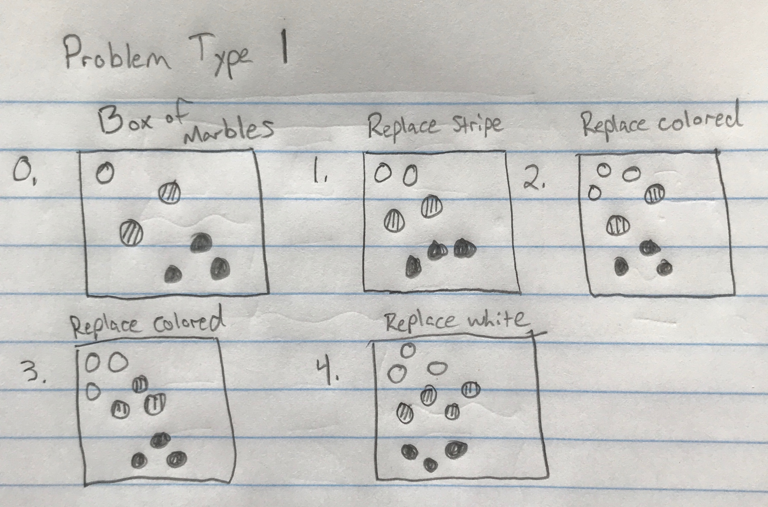

Problem Type 1 required a starting box of marbles of at least three different colors, and each color is of a different quantity inside the box.

The steps above are determined as follows:

Choose a marble and replace it with a different color marble, but also add a marble of the chosen color back to the box.

After enough steps, stop and consider probabilities.

For step 1, I chose to replace a striped marble with a white one, and then added a stripe back.

Step 2, I replaced a colored marble with a white marble again.

Step 3, I replaced a colored marble with a striped marble.

Step 4, I replaced a white marble with a striped marble.

The final marble count inside the box:

White – 3

Striped – 4

Colored – 3

The **final** probabilities for each color are as follows:

White – 3/10

Striped – 4/10 OR 2/5

Colored – 3/10

Compared to the **original** probabilities:

White – 1/6

Striped – 2/6 OR 1/3

Colored – 3/6 OR ½

How did the probability of pulling a white marble change?

It increased very slightly

How did the probability of pulling a striped marble change?

It increased from 1/3 to 2/5

How did the probability of pulling a colored marble change?

It decreased by the highest factor, changing from ½ chance to 3/10 chance.

Problem Type 2 required three different colors of marbles and a box for each color.

Each box contains an unspecific handful of marbles of each color.

Of the three boxes created, one of the boxes were randomly chosen to take a marble from.

This marble was then placed into the next random box between the two remaining.

Of all the marbles in the second box, one random marble was chosen and placed in the final box. A marble was then drawn and probabilities calculated.

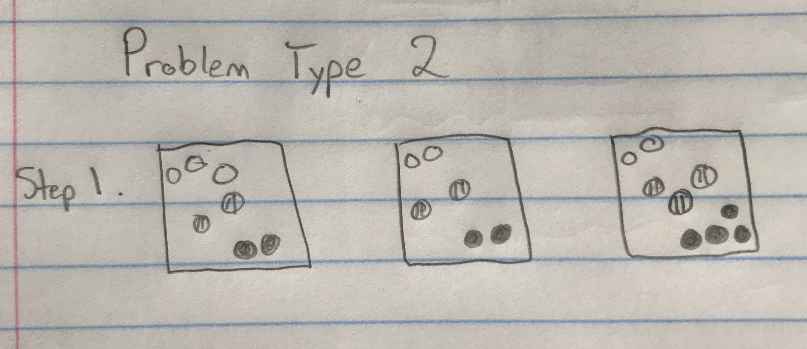

Step 1: Randomly choose a marble from a random box.

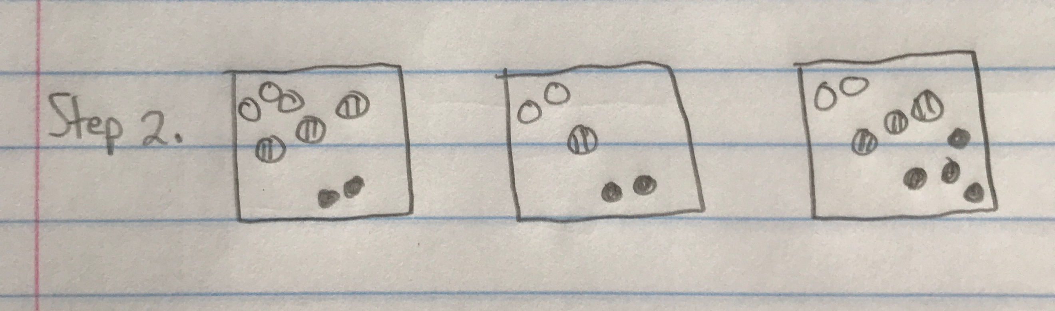

Step 2: Place marble into random box between the last two.

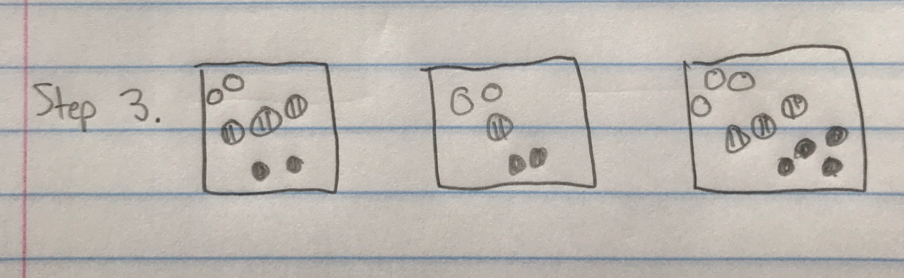

Step 3: From the second box, take a random marble and place it in the final box. Calculate probabilities.

Since box 3 was the final box, the probabilities there will be compared.

Original: White – 2/9 Final: White – 3/10

Striped – 3/9 or 1/3 Striped – 3/10

Colored – 4/9 Colored – 4/10

Of these probabilities, every one decreased or stayed relatively the same.

Activity 4: April 17, 2018 – Magic Tolls

PROBLEM RESTATEMENT – Using a grid of chosen dimensions, calculate the toll based on the rules of movement

QUESTIONS –

What is the cheapest route through a simple 2x2?

What is the most expensive route through a simple 2x2?

How do standard routes through a 2x2 compare?

Would a zig-zag technique through a 2x4 be similarly effective to the cheapest route?

How do routes compare in a 4x3?

~~~~~~~~~~~~~~~~~~~~~~~~~~~~~~~~~~~~~~~~~~~~~~~~~~~~~~~~~~~~~~~~~~~~~~~~~~~~~~

The rules of movement for the magic band:

Start in the top-left corner with a value of 1, end in the bottom-right.

Moving RIGHT adds 2 to your toll.

Moving LEFT subtracts 2 from your toll.

Moving DOWN doubles your current toll.

Moving UP halves your current toll.

The goal: Find the cheapest and most expensive routes and compare them to other routes.

To begin, I’ll use a 2x2 square grid similar to the one below:

START

END

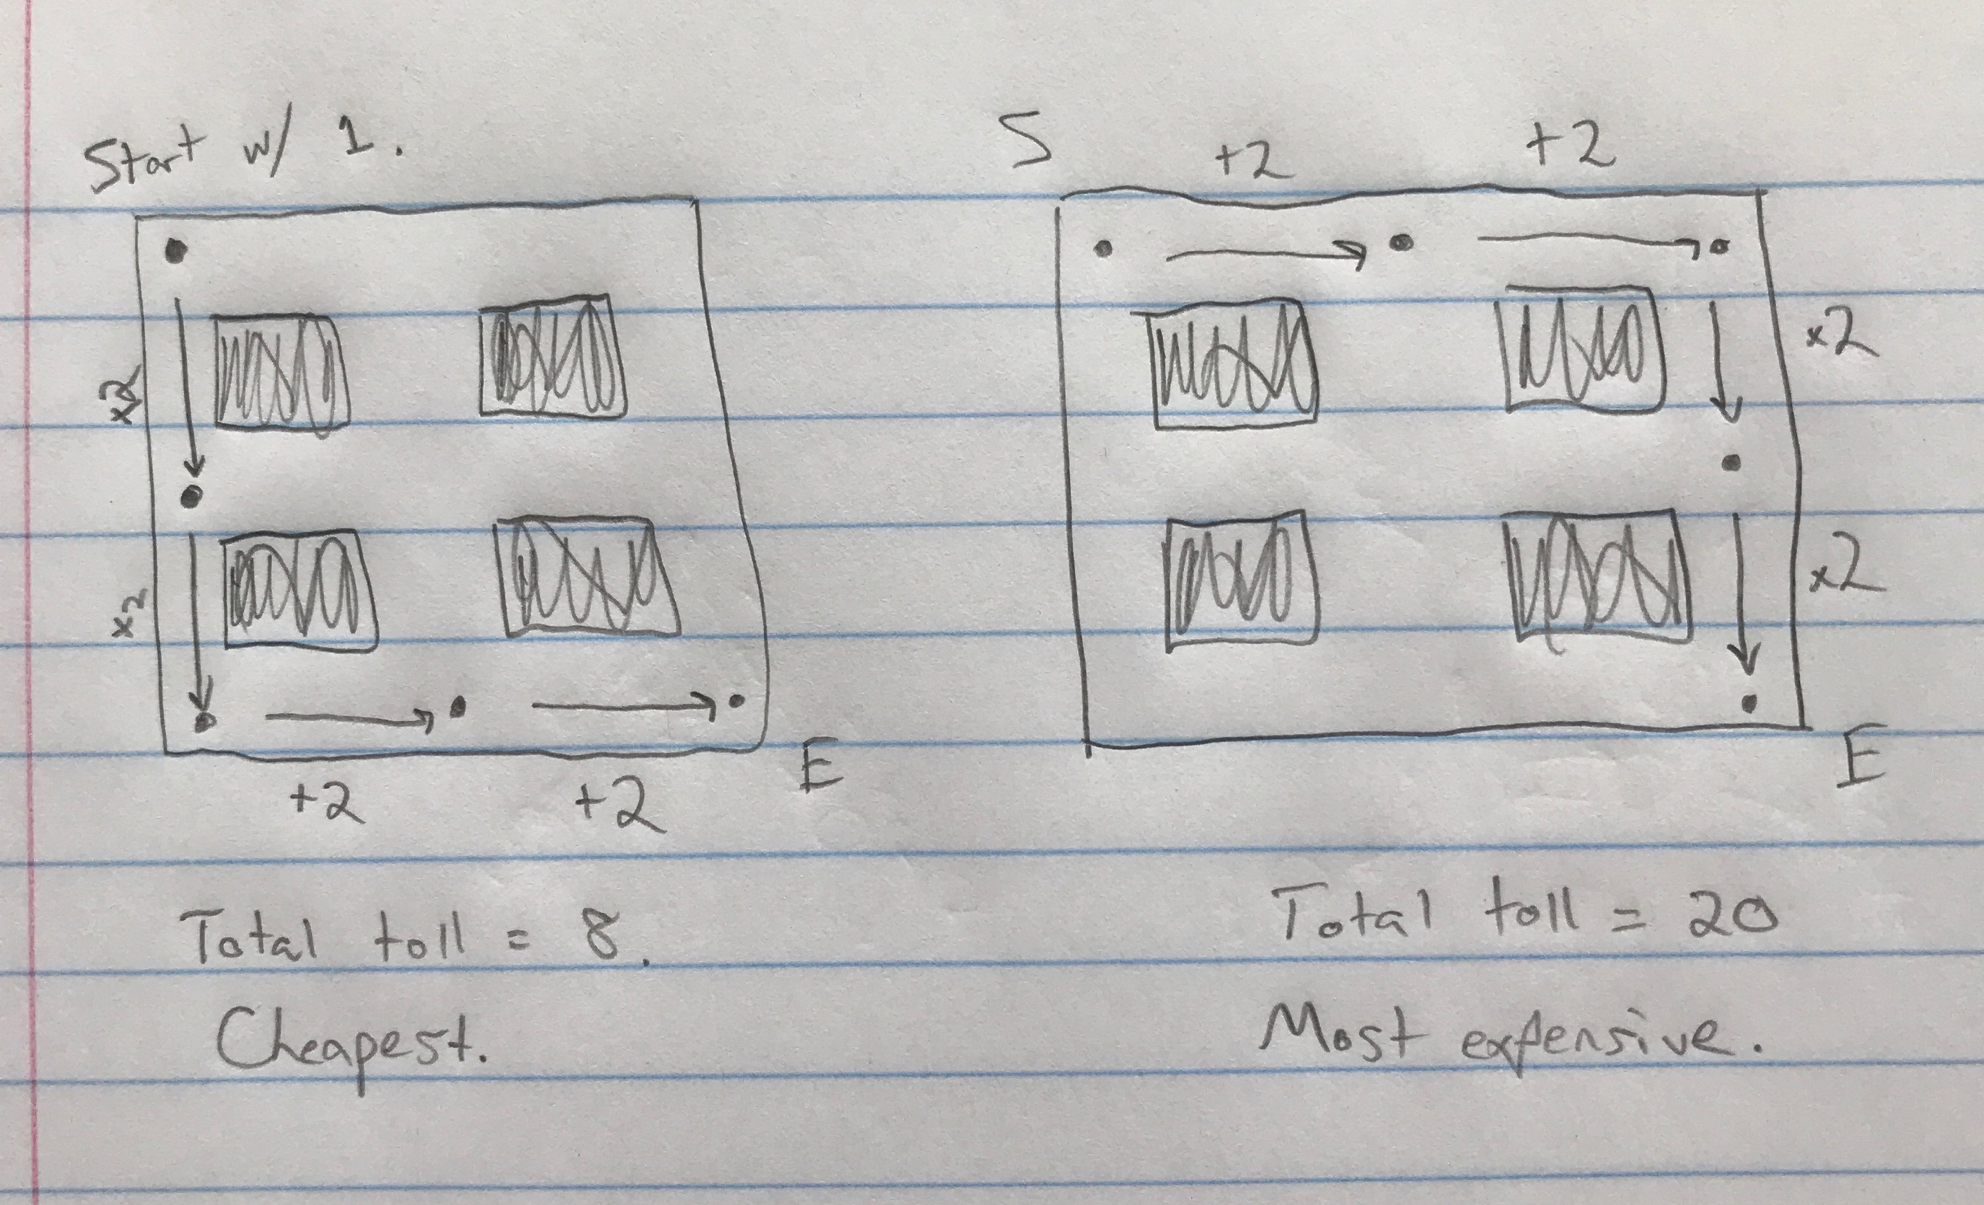

This first grid shows that the cheapest route required a toll of 8, and took the route around the left and bottom side of the grid.

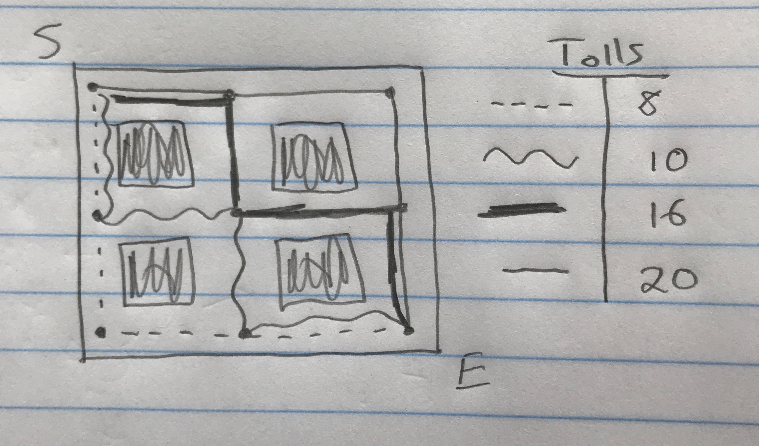

I then attempted to compare the cheapest and most expensive routes to two alternate routes that went through the middle. The toll values did not change much but going through the middle of the grid increased the price slightly while staying below the most expensive route.

For an experimental turn, I drew a 2x4 grid and compared a zig-zag route to the cheapest route to see how efficient zig-zagging could be.

My thoughts were that the alternating up’s and down’s would successfully half the value and keep it from growing too large.

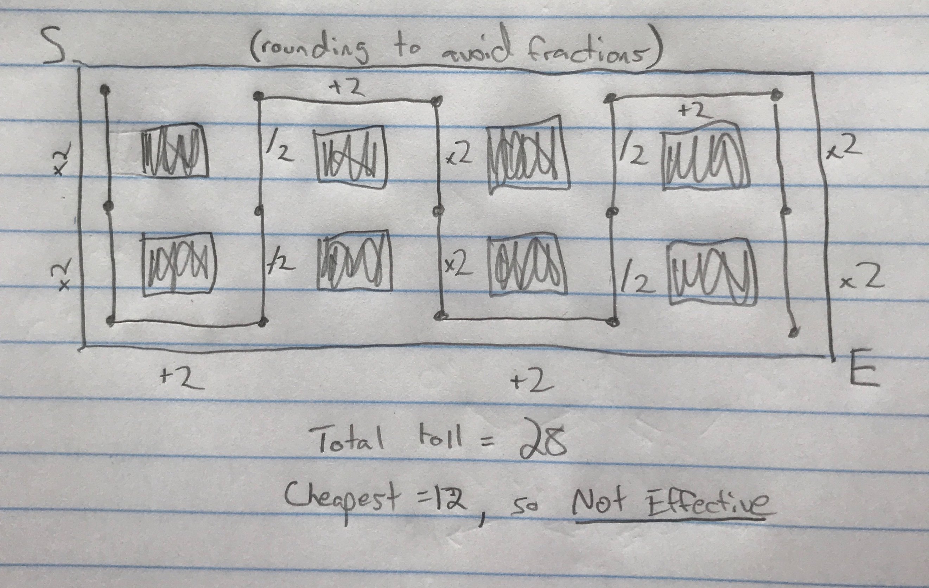

The zig-zag method did not function as was hoped. While it was not extremely expensive compared to the cheapest route, it was more than double and is therefore not effective at all.

In a final experimental effort, I drew a 4x3 rectangular grid and compared the outside routes to one that zig-zagged through the middle.

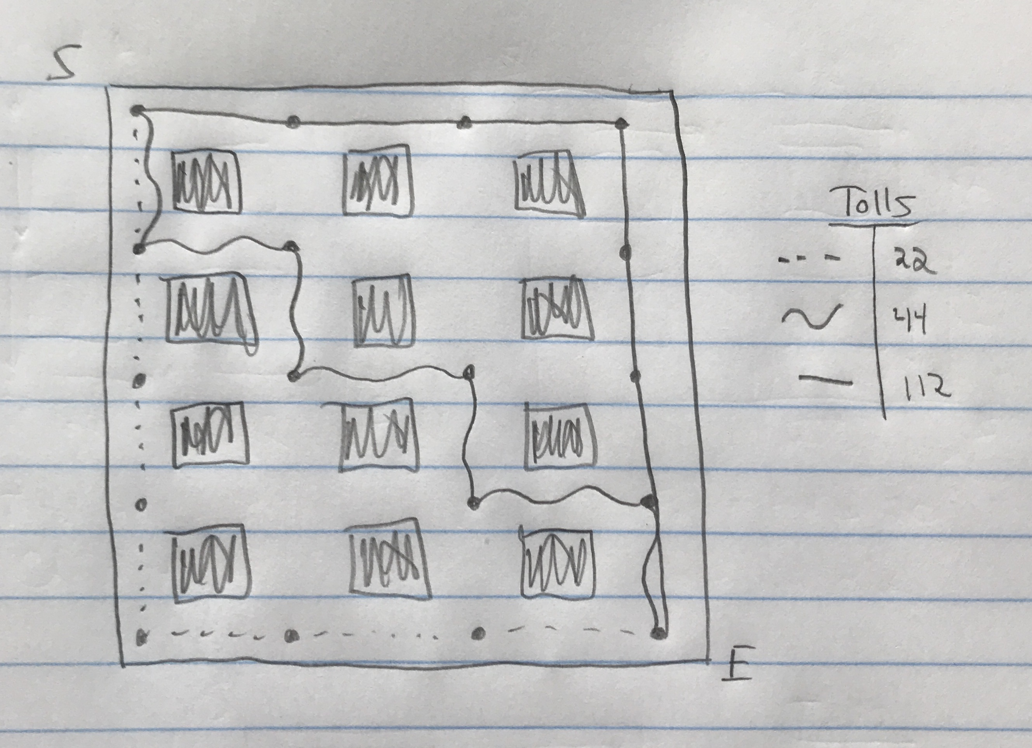

This method shows that cutting through the middle could prove slightly effective compared to using the most expensive route. The middle route was double the price of the cheapest route but was also almost a third of the most expensive route.

Activity 5: April 19, 2018 – Sophisticated Chip Firing

PROBLEM RESTATEMENT – Using three directed graphs, find the probability of reaching the success nodes.

QUESTIONS –

How many tosses will it take before the success goal of 4 like flips in a row is achieved?

How hard is it to toss a perfect round?

Does partial order add to the complexity of the tossing method?

How does chip firing in a ring graph work?

Will the success probabilities be different in ring graphs?

~~~~~~~~~~~~~~~~~~~~~~~~~~~~~~~~~~~~~~~~~~~~~~~~~~~~~~~~~~~~~~~~~~~~~~~~~~~~~~

Sequence of 3 coin tosses

The goal of this sequence is to toss a coin until either three heads are shown in a row, or three tails are shown in a row.

Tosses:

**H, T, T, T** - First round of tossing only required four coin tosses before three tails in a row were seen, giving a ¾ probability of a success

**T, T, H, T, T, H, H, H** - Second round of tossing required 8 tosses before three heads in a row were seen, giving 3/8 probability of success

**T, T, T** - Third round showed a perfect sequence of tossing, only requiring three tosses, all showing tails and giving a 100% probability of success.

Sequence of 4 coin tosses

This graph requires the same process, with a different length. This time it will test for 4 like tosses in a row

**H, T, T, H, T, H, H, T, T, T, T** - First round of tossing required 11 tosses before 4 tails were shown in a row. This gives a 4/11 probability of success

**H, H, H, T, T, T, H, T, T, H, H, H, H** - Second round of tossing fired 13 times before showing 4 heads in a row, giving a 4/13 probability of success

**H, T, T, T, H, H, H, H** - Third round of tossing fired only 8 times, giving a ½ probability of success

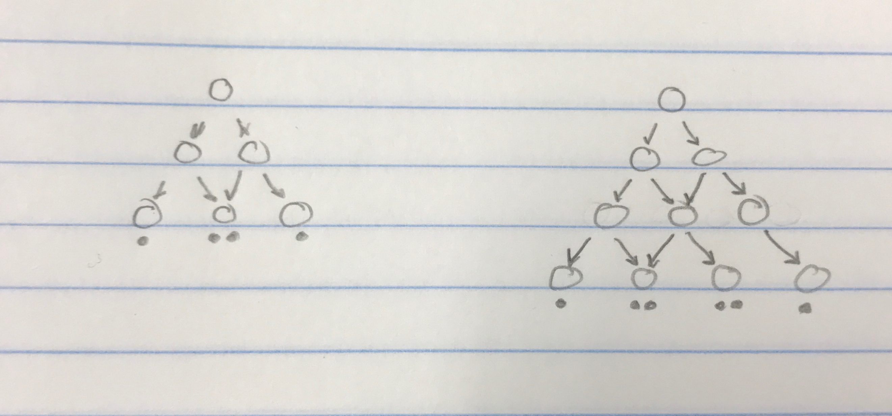**Partial Order Graphs – Bottom Rows of 3 and 4**

The partial order graph on the left shows possible success solutions with 4 chips fired. The leftmost and rightmost solutions show a ¼ probability of success, while the middle solution is a ½ chance.

Switching to the 4 bottom solution graph on the right, the probabilities of achieving success solutions grow more complex. The outermost solutions have 1/6 probabilities of success while the inside two solutions show 1/3 chance.

**Bottom Rows of 5 and 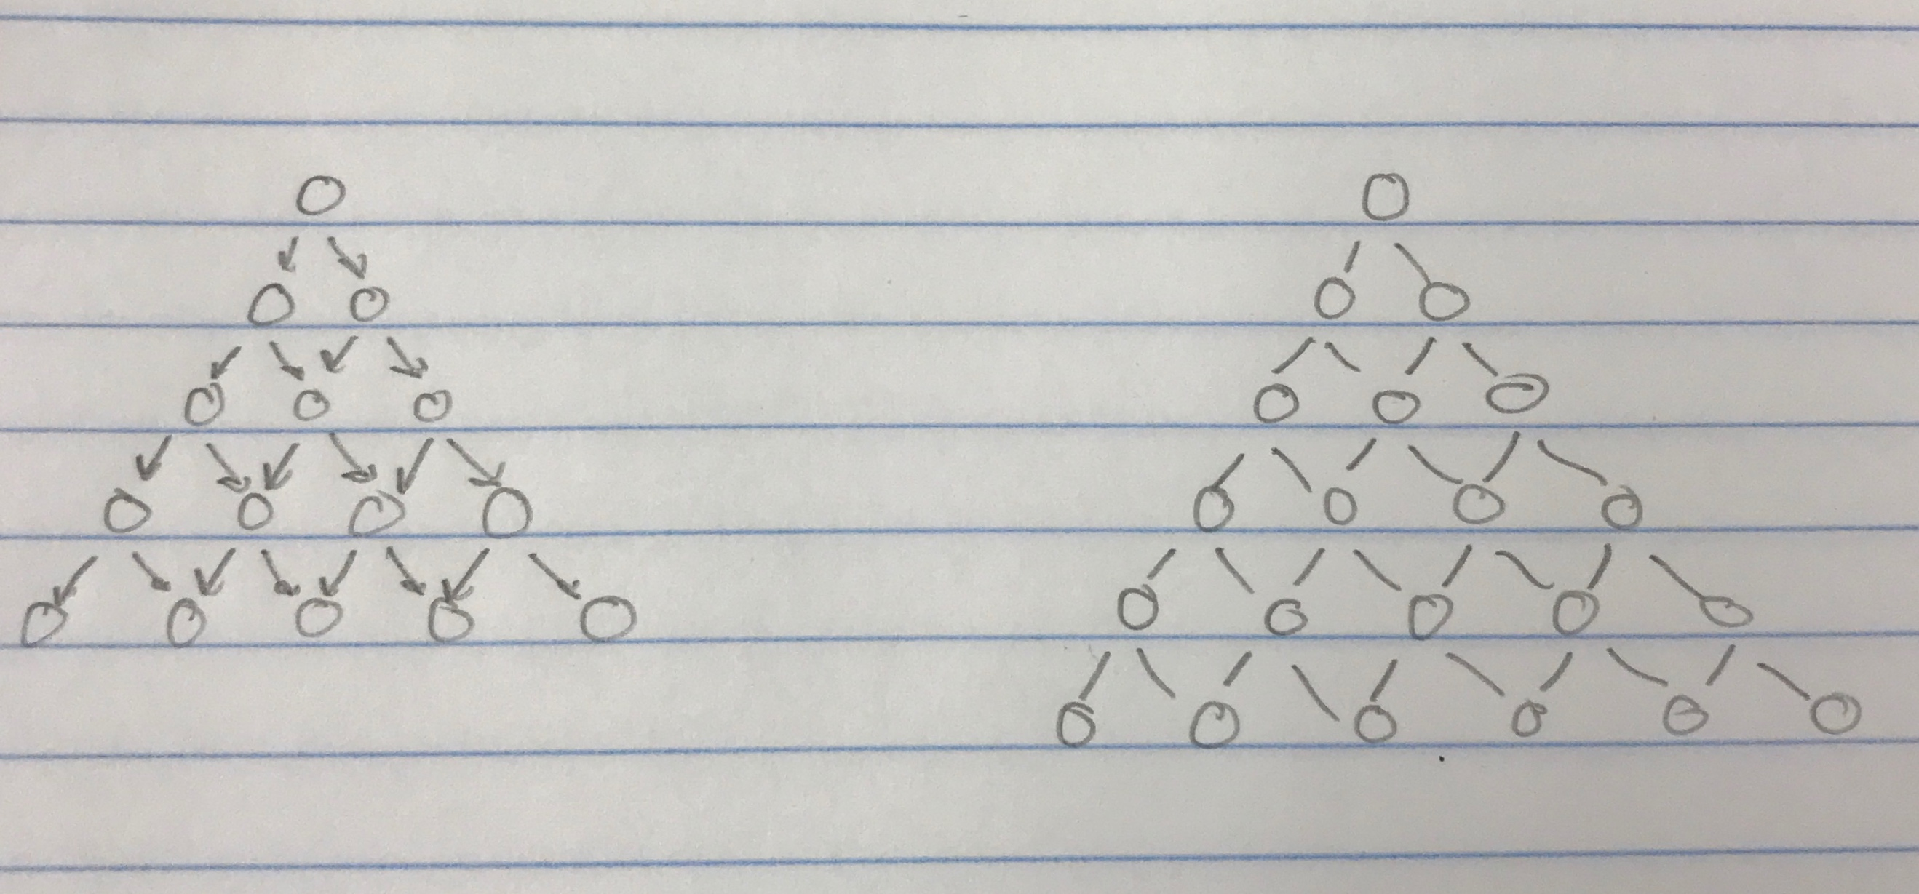6**

The pattern here continues, with solution nodes slowly decreasing in probability of success.

More interior options and the randomness of a coin flip makes these probabilities more unlikely as the graphs get larger.

The left graph pictures partial order with a bottom row of 5. The leftmost success node has a 1/8 chance of success, as does the rightmost. The inner solution nodes have a ¼ chance of success.

As for the graph on the right, this has a bottom row of 6, giving its left- and rightmost solutions a 1/10 chance and the inner solutions a 1/5 chance.

**Bottom Row of 7**

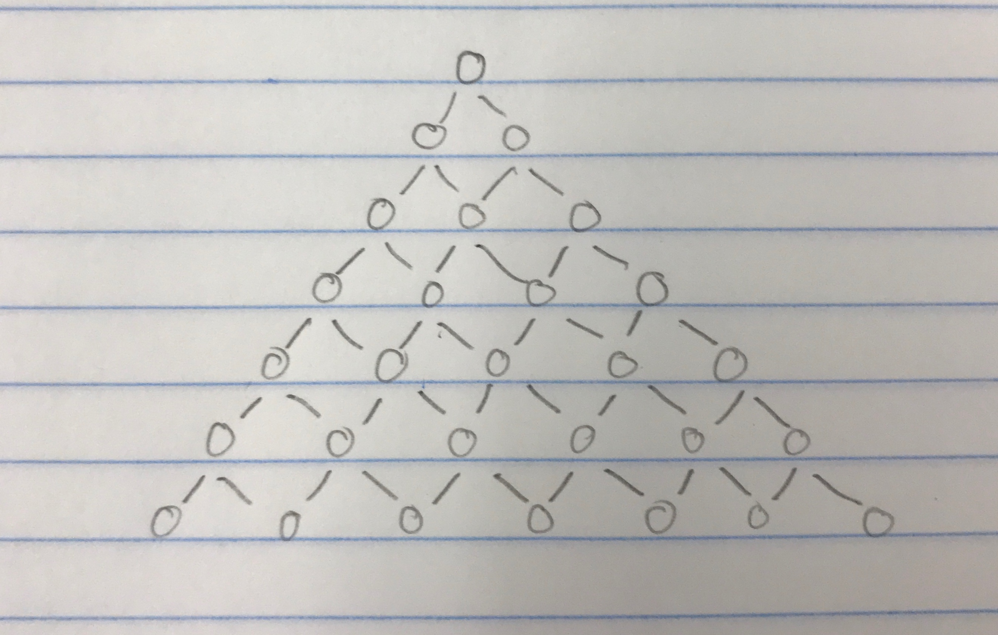

The final partial order graph shows a bottom row of 7, giving the outermost solutions a success probability of 1/12. This is an increase by a factor of 3 from the original 3 bottom graph

Ring Graphs of 3, 4, 5, 6

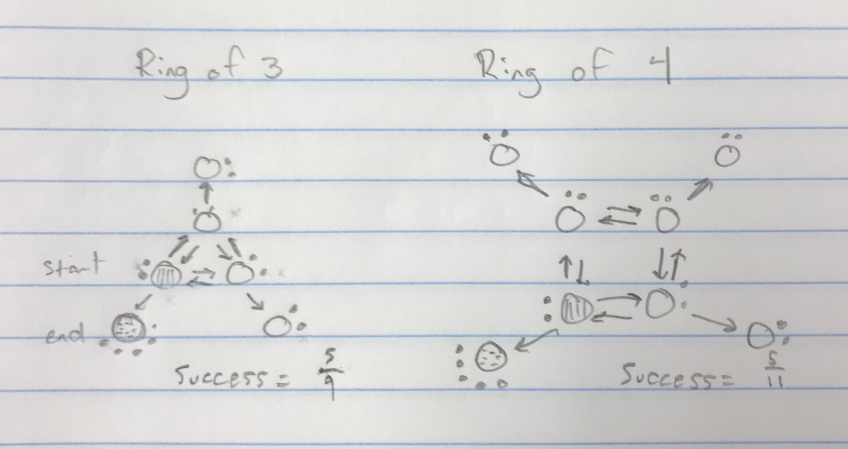

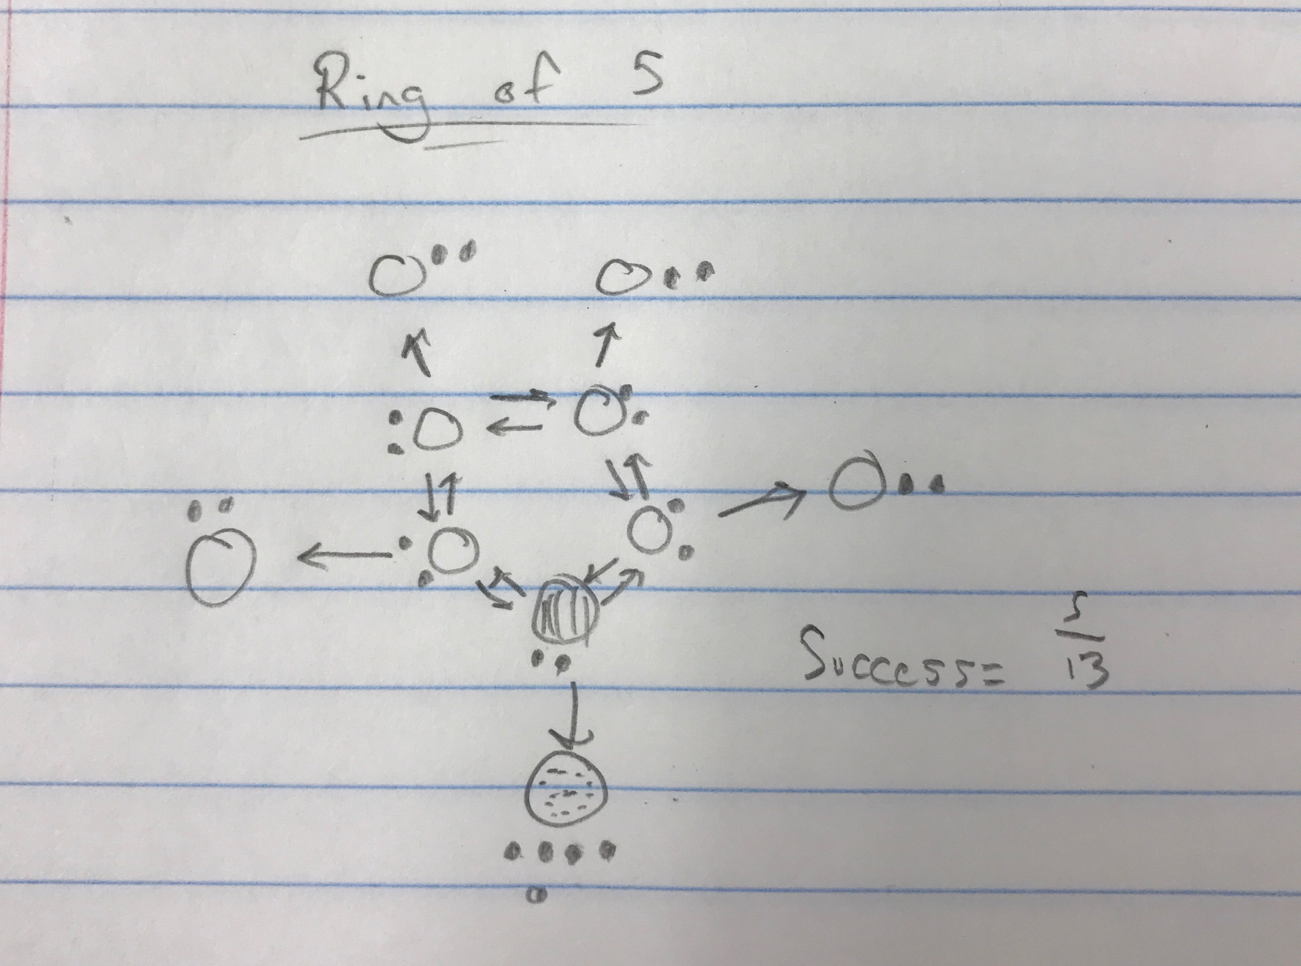

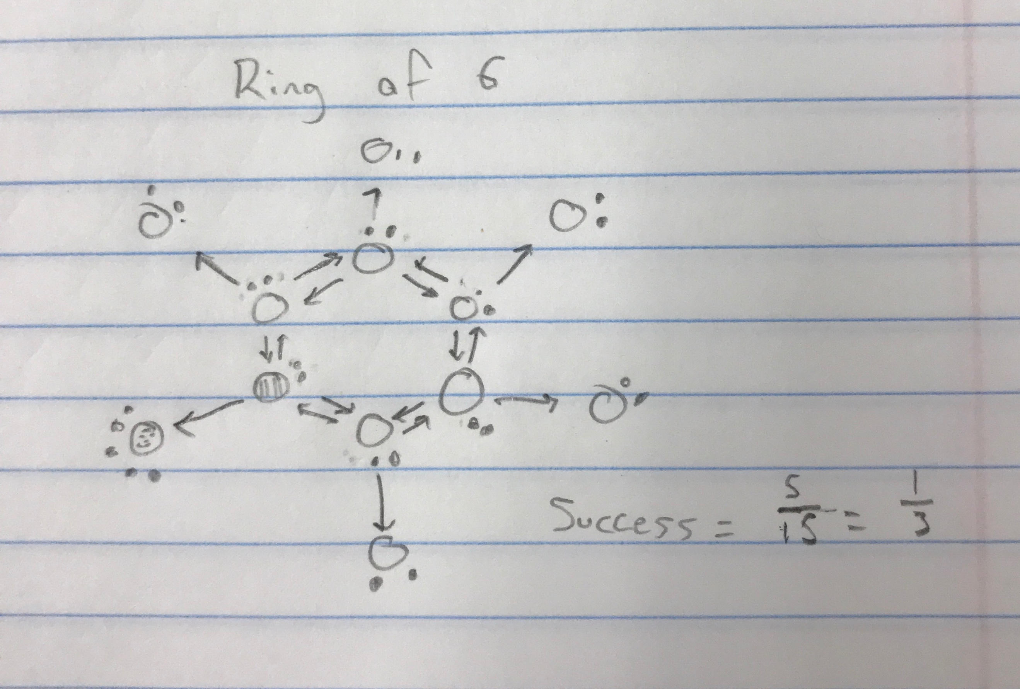

To accomplish chip firing in a ring graph, fill all interior nodes within one chip of critical state. Adding chips to the start node causes it to fire to every node it is touching. These chips transfer around the ring until no nodes are able to be fired or the chips return to the start node. If nothing can be fired and the nodes are not full, add chips to the start node and continue firing. When all nodes are full, divide the amount of chips in the end node by all chips in the exterior.

Activity 6: April 24, 2018 – Pigeon-Hole Principle

PROBLEM RESTATEMENT – Considering three types of proof problems, explore and prove scenarios in each

QUESTIONS –

Can any three adjacent integers on a circle add up to k?

What is the maximum k possible on any given circle?

How many handshakes are given/received in a situation?

Can a sequence of numbers in a list have gaps or must they be directly consecutive?

~~~~~~~~~~~~~~~~~~~~~~~~~~~~~~~~~~~~~~~~~~~~~~~~~~~~~~~~~~~~~~~~~~~~~~~~~~~~~~

**Problem 1** asks to prove that of consecutive integers to n, any m adjacent integers add up to k.

The first picture uses the numbers as shown in the example.

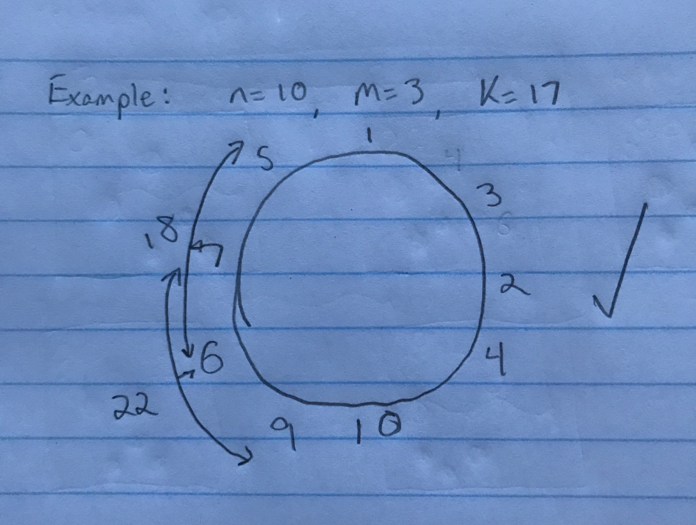n = 10, m = 3, k = 17.

3 adjacent integers along the circle were chosen.

7 + 6 + 9 = 22. 22 > 17

5 + 7 + 6 = 18. 18 > 17

Proven that three integers along the circle will add to equal a given k.

This integer k that is the goal does have a limit however.

K has a maximum possible value equal to the largest m numbers on the circle.

In this case, the maximum possible k was 10 + 9 + 8 = 27

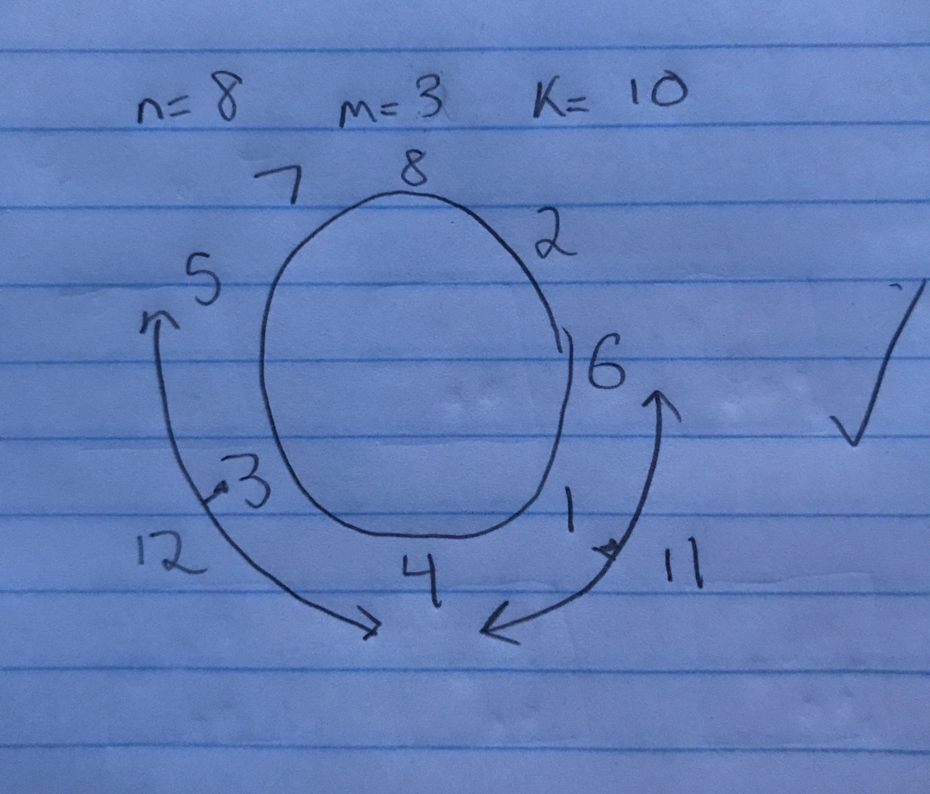

This second circle had chosen values as follows: n = 8, m = 3, k = 10

To prove that any 3 adjacent values from 1 to 8 along the circle add to 10 or greater.

5 + 3 + 4 = 12

6 + 1 + 4 = 11

The maximum possible k value in this circumstance was 8 + 7 + 6 = 21

**Handshakes**

There are n people in a room and each person shakes hands with every other person in the room ONCE. Simple math can prove that two different people both shook hands with the same amount of people.

For instance: n = 5.

5 people walk into a room and each person shakes hands with the other 4 people.

Person 1 shook hands with 4 different people.

Person 2 also shook hands with 4 different people.

Altogether, there were 20 handshakes throughout the room, with each person contributing 4 handshakes.

To determine the total number of handshakes in ANY given situation, the formula

n * (n-1) can be used. The integer n is multiplied by (n-1) and not n because you cannot shake hands with yourself and are therefore excluded from the total handshakes you can give.

In a room of n = 20 people, each person will contribute 19 handshakes and the total handshakes count is [n * (n-1)] or [20 * (20-1)] = 380 handshakes

**Integer List**

The goal in this problem is to prove that of a list of any n integers, a sequence of consecutive numbers in the list will add to be a multiple of n.

n = 3

4, 15, -3

In the above list, two consecutive numbers should add to be a multiple of n (3).

15 + (-3) = 12, a multiple of 3

n = 6

1, 4, -4, 10, 5, 2

In the above list, any sequence of consecutively listed numbers will add to be a multiple of n (6)

In this list, there exists only two consecutive numbers that add to be a multiple of 6.

-4 + 10 = 6.

n = 10

-3, 14, 8, -10, 2, 6, 4, 1, 7, 3

In the above list, multiple sequences of consecutive integers add to equal a multiple of 10.

6 + 4 = 10

7 + 3 = 10

**Post Test Results and Analysis**

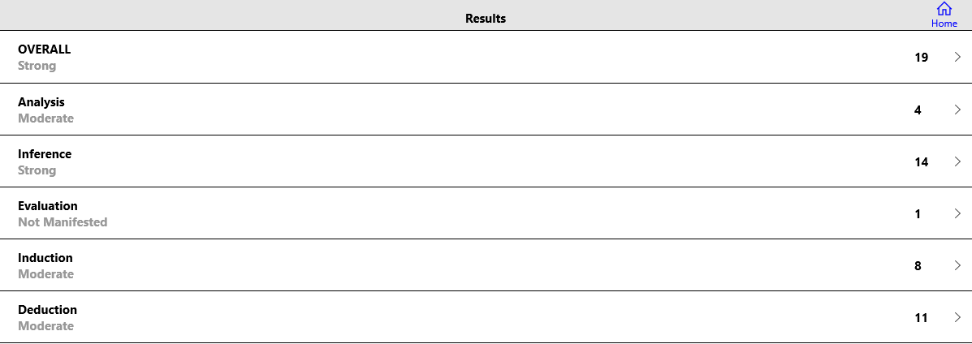

This time around, taking the test/survey felt different both in the way I went about answering the questions and the results I received.

I have taken this exact test multiple times over the course of my career at Clemson and have never once felt a significant change in my thinking towards these problems… until this class.

I felt myself approach the questions from a different perspective than what I did before.

I interpreted some questions differently than before and had quite a few “AHA!” moments where I better understood what the question was asking.

I believe this was proven in my scores above. I could not find the screenshot of my pre-test at the beginning of the semester, but I do clearly remember not receiving a single score of “Strong.” In this test I received two areas with a “Strong” score and am actually quite happy with seeing my results. This class has taught me perception techniques in questions, how to answer tricky questions, and how to branch out in my thinking to come to a more creative (and sometimes accurate) answer.